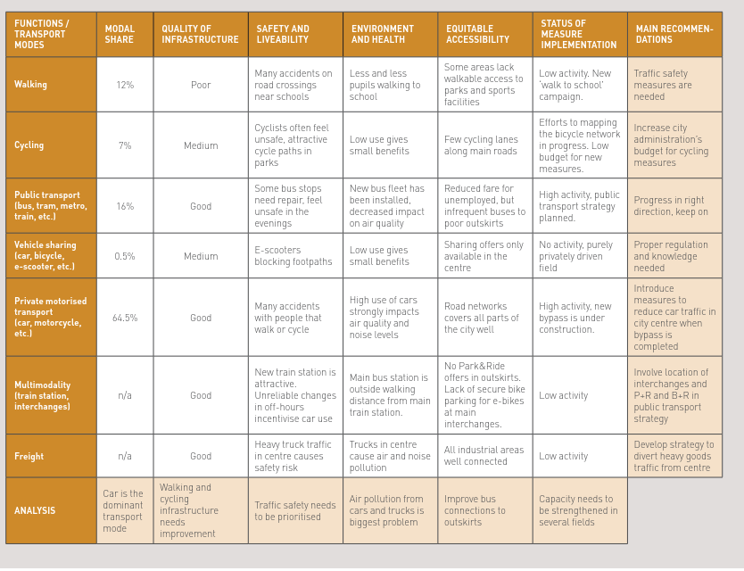
Task 1. Prepare a baseline analysis
The first task is to prepare a baseline analysis of the mobility situation in your city. You can use the analysis table 1 to define the status of the transport system – the baseline.

Example of how analysis table has been used can be utilised as inspiration.

The table has ben adapted from SUMPs-Up Manual on the integration of measures and measure packages - start, p. 10., https://sumps-up.eu/fileadmin/user_upload/Tools_and_Resources/Publications_and_reports/Manuals/SUMPs-Up_-_Measure_Selection_Manual_-_Beginner_Cities.pdf

Table 1: Analysis table for defining the status of the transport system

Function/Transport modes | Modal share | Quality of infrastructure | Safety and livability | Environment and health | Equitable accessibility | Status of measure implementation | Main recommendations
Walking
Cycling
Public transport (buc, tram. metro, train etc.
Vehicle sharing (car, bicycle, e-scooter etc.
Private motorised transport (car, motorcycle etc.
Multimodality (train, station interchanges)
Freight
Analysis

